Name: Gaurav Kumar Singh

Registration Number: 19BCE2119

Course: Web Technologies

1. A parking garage charges a $2.00 minimum fee to park for up to three hours. The garage charges an additional $0.50 per hour for each hour or part thereof in excess of three hours. The maximum charge for any given 24-hour period is $10.00. Assume that no car parks for longer than 24 hours at a time. Write a script that calculates and displays the parking charges for each customer who parked a car in this garage yesterday. You should input from the user the hours parked for each customer. The program should display the charge for the current customer and should calculate and display the running total of yesterday's receipts. The program should use the function calculate-Charges to determine the charge for each customer. Use a prompt dialog to obtain the input from the user.

**CODE:**

**HTML**

<html>

<head>

  <title>Parking garage charges</title>

  <meta charset="utf-8">

  <script type="text/javascript" src="./1.js">

  </script>

</head>

<body onload="inputData();">

  <h1> Welcome to the program to calculate the parking garage charges</h1>

  <hr>

  <p>

    Hours parked:<input type="text" id="hrsParked"><br>

    Charges:<input type="text" id="charges"><br>

  </p>

  <button onclick="doCalculation()">Capture the Charges</button>

</body>

</html>

**JavaScript**

var currentCustomer = 0;

var totalCharges = 0;

  function calculate_Charges(hrs){

    var charges = 2;

    if (hrs > 3)

        charges += Math.ceil(hrs - 3) * 0.5;

    if (charges > 10)

        charges = 10;

    totalCharges += charges;

    return charges;

  }

  function doCalculation(){

        var hrsParked = parseFloat(document.getElementById("hrsParked").value);

        var charges = calculate_Charges(hrsParked);

        document.getElementById("charges").value = charges;

  }

function calculateChargesForOneCustomer()

{

currentCustomer++;

var hrsParked = parseFloat(prompt("Please enter the hours parked for customer: ", ""));

var charges = calculate_Charges(hrsParked);

document.write("<tr><td>Customer " + currentCustomer + "</td><td align='right'>" + hrsParked + "</td><td align='right'>" + charges.toString() + "</td></tr>");

}

function inputData()

{

document.write("<table><th>Customer</th><th>Hours Parked</th><th>Charges</th>");

var addCustomer = 'Y';

while (addCustomer == "Y")

{

    calculateChargesForOneCustomer()

    addCustomer = prompt("Add a Customer? ", "Y");

}

document.write("<tr><td/><td/><td align='right'><b>$" + totalCharges.toString() + "</b></td></tr>");

document.write("</table>");

}

**SCREENSHOTS:**

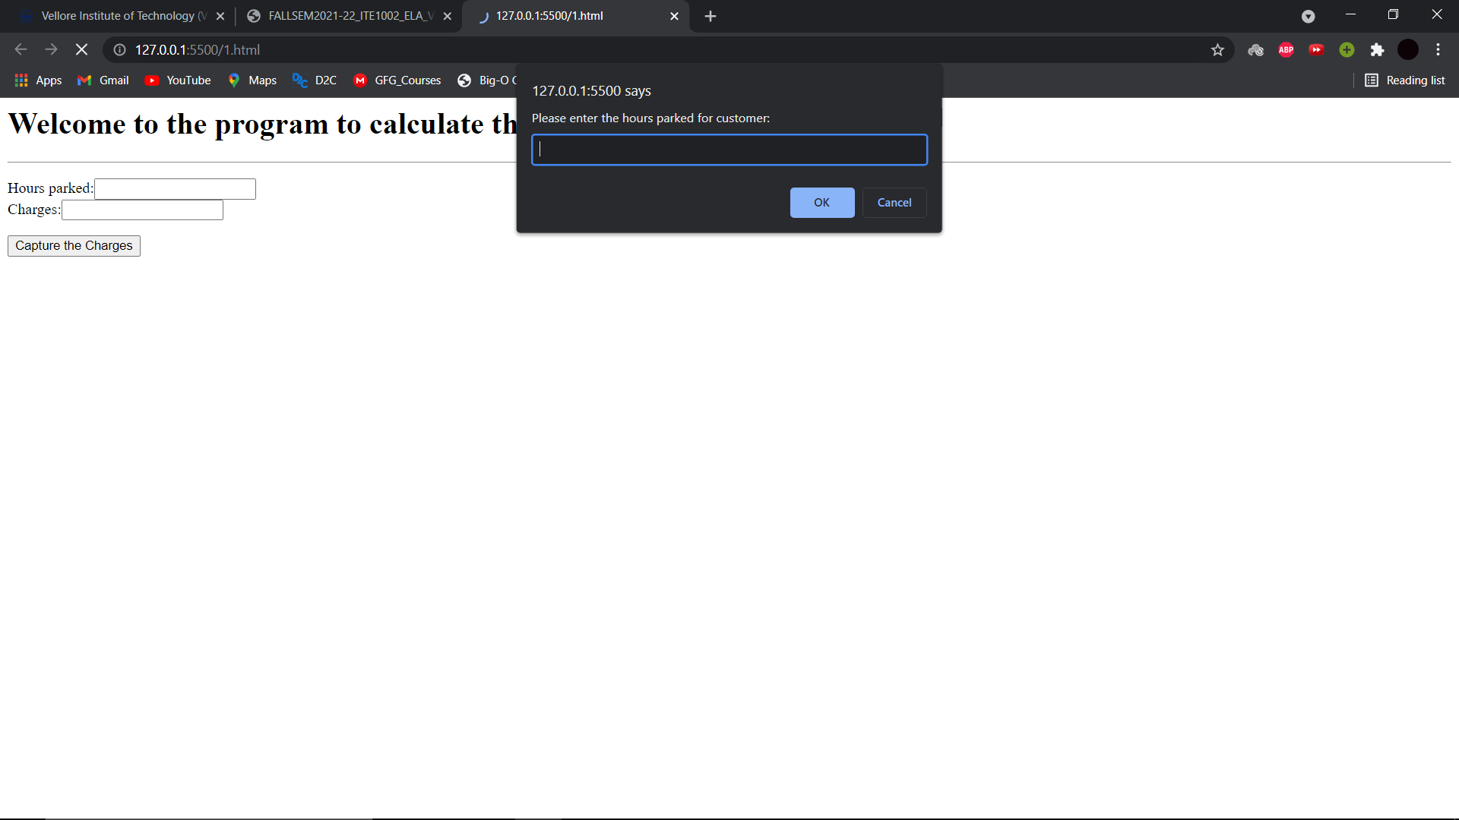

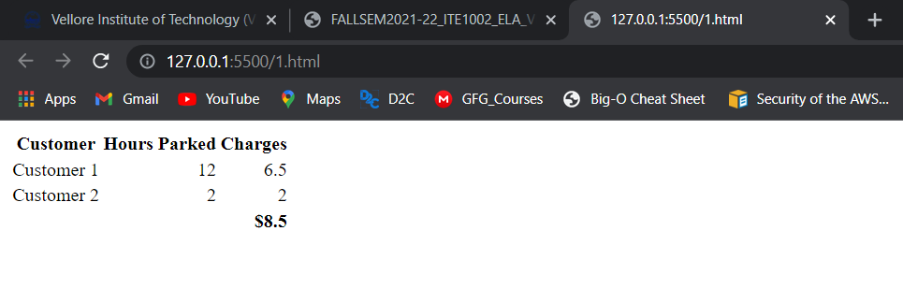

1. Create a web page containing three divisions.

a) The first division displays a digital clock on the rightmost end.

b) The width of the first division is 100%. The second division and third division lay side by side.

c) The second division has an image slider and third division has a colour picker and two list boxes having font-family and size and a button. When a button is clicked the background colour, font and font size should change for a whole page. Use JavaScript to implement the above.

**CODE:**

**HTML**

<!DOCTYPE html>

<html lang="en">

<head>

    <meta charset="UTF-8">

    <meta http-equiv="X-UA-Compatible" content="IE=edge">

    <meta name="viewport" content="width=device-width, initial-scale=1.0">

    <title>Document</title>

    <link rel="stylesheet" href="2.css">

</head>

<body>

    <div class=digiclock>

        <h2 id=clock>Time- </h2>

    </div>

    <div class=flex-s>

        <div class=img-slider>

            <img id=ximg src="testimg.jpg"><br>

            <button onclick="back()">Back</button>

            <button onclick="next()">Next</button>

        </div>

        <div class=clrpicker>

            <form method="GET" id="form">

                Color: <input type=color name=color id=color value="#ffffff"><br><br>

                Font-Family: <select name=family>

                    <option value="Times New Roman, Times, serif">Times New Roman</option>

                    <option value="Arial, Helvetica, sans-serif">Arial</option>

                    <option value="Lucida Console, Courier New, monospace">Lucida Console</option>

                </select><br><br>

                Font-Size: <select name="size">

                    <option>10px</option>

                    <option>15px</option>

                    <option>20px</option>

                    <option>30px</option>

                </select>

            </form>

            <br>

            <button onClick="Format()">Format</button>

        </div>

    </div>

    <script src="2.js"></script>

</body>

</html>

**CSS**

.digiclock{

    width: 100%;

    text-align: center;

    font-size: 30px;

}

.img-slider{

    width:50%;

    height:200px;

    background-color:red;

}

#ximg{

    width:100%;

    height:100%;

    background-repeat: no-repeat;

    background-size: cover;

}

.flex-s{

    display:flex;

    flex-direction:row;

    flex-wrap: nowrap;

}

.clrpicker{

    width:50%;

    height:200px;

    padding-left:20px;

}

**JavaScript**

function digitalclock(){

    var today = new Date();

    var time = today.getHours() + ":" + today.getMinutes() + ":" + today.getSeconds();

    document.getElementById("clock").innerHTML="Time- "+time;

}

setInterval(digitalclock, 1000);

function Format(){

    var form= new FormData(document.getElementById("form"));

    var color= form.get("color");

    var family= form.get("family");

    var size= form.get("size");

    var bstyle=document.querySelector("body").style;

    bstyle.backgroundColor=color;

    bstyle.fontFamily= family;

    bstyle.fontSize = size;

}

var imgarr=["testimg.jpg", "testimg1.jpg", "testimg2.jpg"];

var count=0;

var imgselector=document.getElementById("ximg");

function back(){

    count--;

    imgselector.src=imgarr[Math.abs(count)%3];

}

function next(){

    count++;

    imgselector.src=imgarr[Math.abs(count)%3];

}

**SCREENSHOTS:**

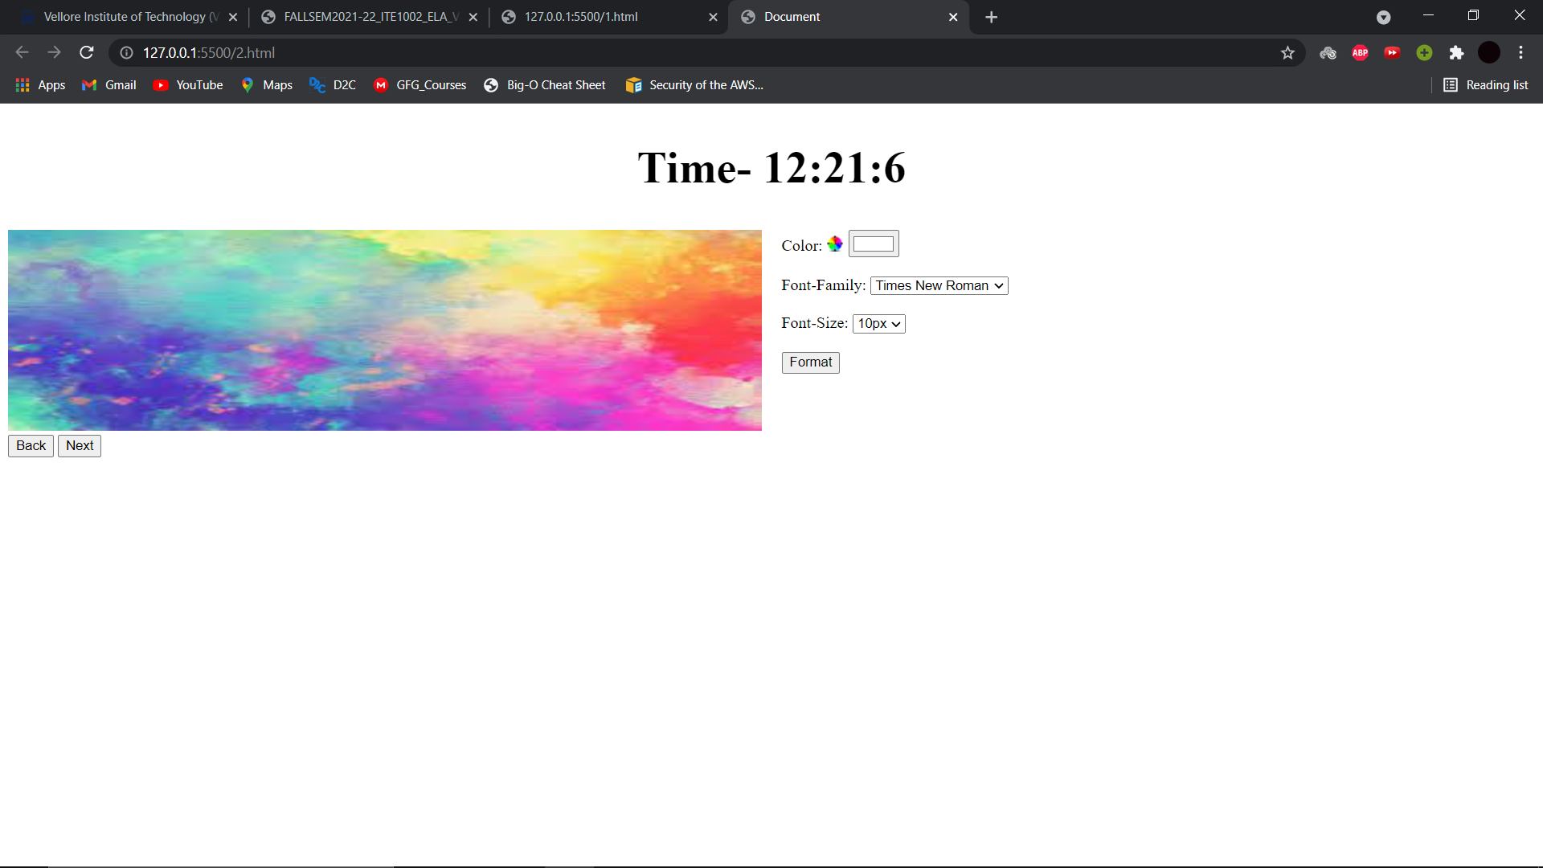

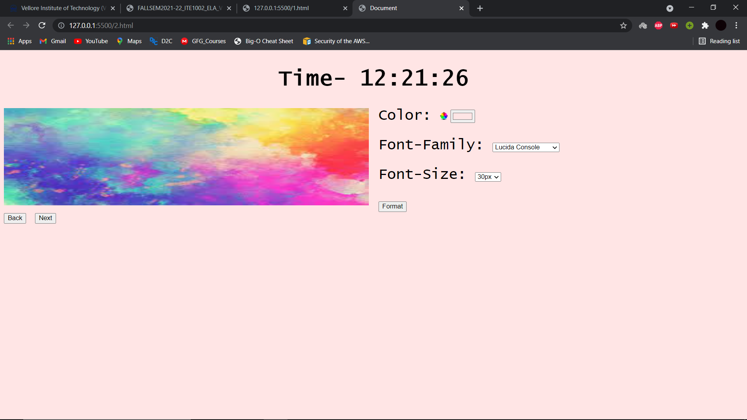

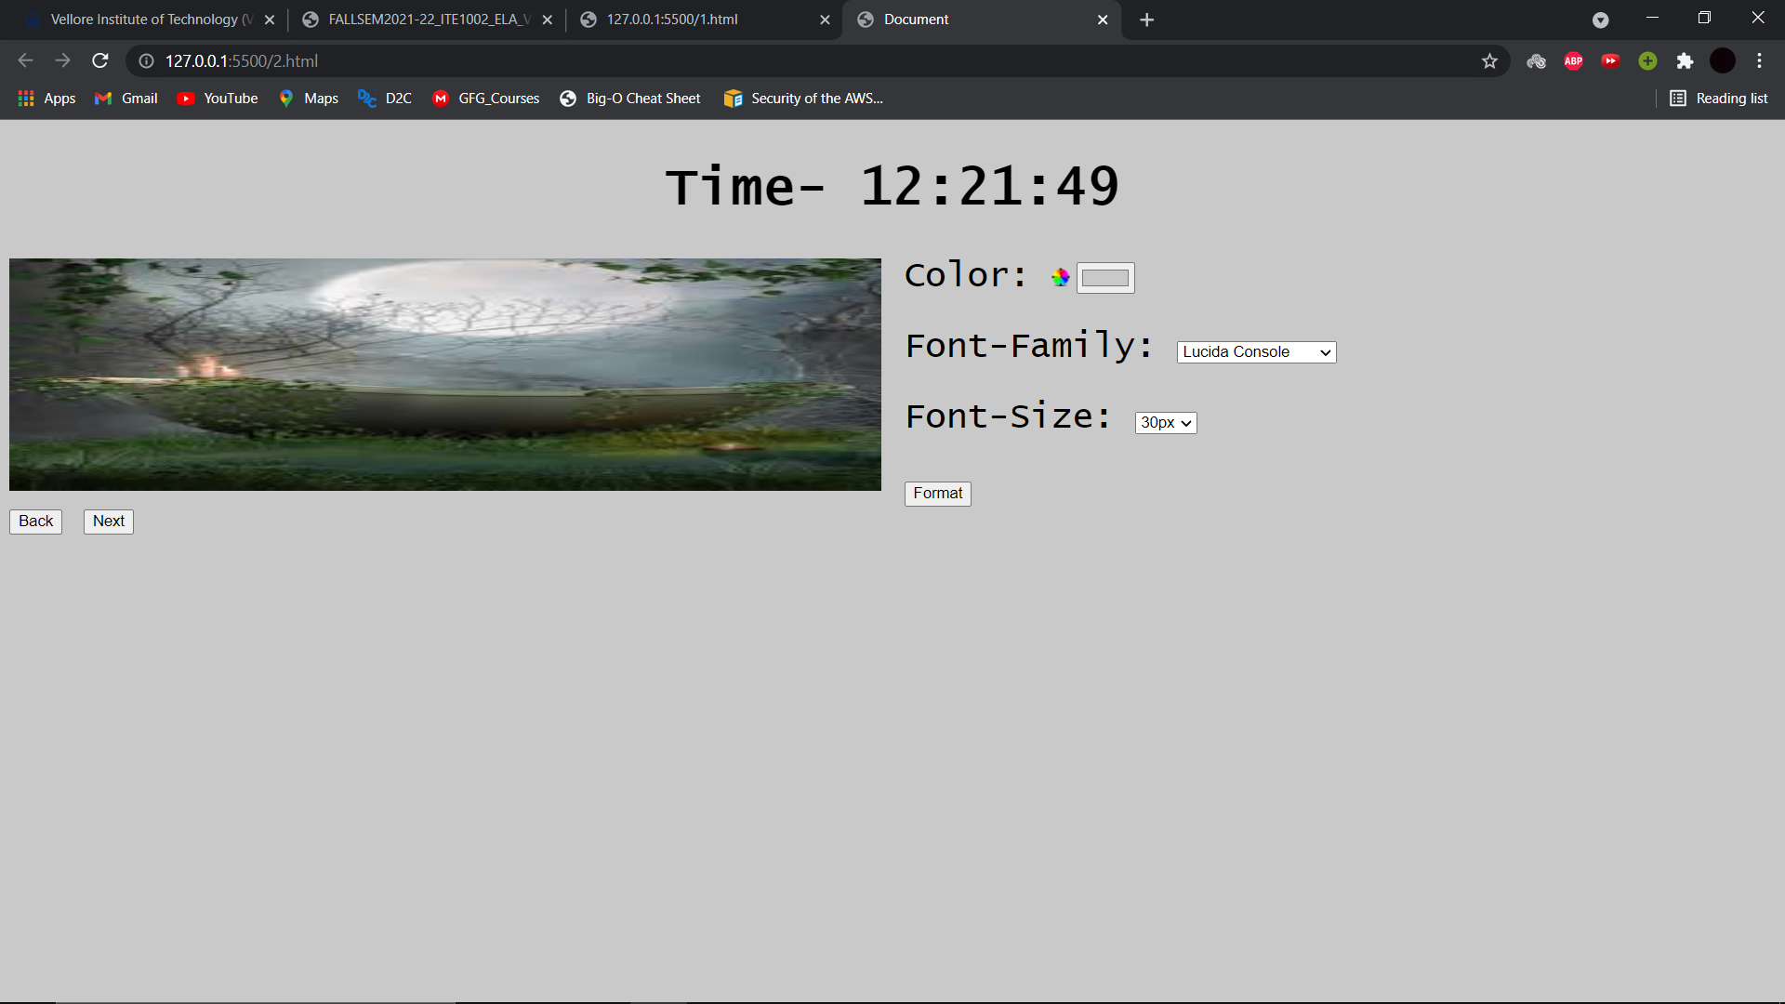

1. Design a student registration form which takes student name, register number, DOB, program, email id, temporary address, permanent address, phone number. Validate the following using JavaScript:

a) Mobile number should be exactly 10 digits.

b) Register number should have alphabets and numbers only.

c) Name should not exceed 30 characters and can be only alphabets.

d) Email validation.

e) Provide a checkbox saying “Permanent address is same as temporary address”. If checked, the value of permanent address should be added automatically from temp address. And should be in disabled mode.

**CODE:**

**HTML**

<html>

<head>

<title>Registeration</title>

<script type="text/javascript" src="./3.js"></script>

</head>

<body>

    <center>

    <form>

    <table>

    <tr>

        <td>Student Name:</td><td><input name="name" id="name" type="text" maxlength="30"></td>

    </tr>

    <tr>

        <td>Register Number:</td><td><input id="regno" type="text"></td>

    </tr>

    <tr>

        <td>Date of Birth:</td><td><input id="dob" type="text"></td>

    </tr>

    <tr>

        <td>Program:</td><td><input id="prog" type="text"></td>

    </tr>

    <tr>

        <td>E-Mail ID:</td><td><input id="email" type="text"></td>

    </tr>

    <tr>

        <td>Temporary Address:</td><td><input id="tempadd" type="text"></td>

    </tr>

    <tr>

        <td>Permanent Address:</td><td><input id="permadd" type="text"></td>

        <td><input id="check" type="checkbox" onclick="disable();">Same as temporary address</td>

    </tr>

    <tr>

        <td>Phone Nummber:</td><td><input id="phoneno" type="text" maxlength="10"></td>

    </tr>

    <tr><td colspan="2"><input type="submit" onclick="validate();"></td></tr>

    </table>

    </form>

    </center>

</body>

</html>

**JavaScript**

function validate(){

name(document.getElementById("name").value);

reg(document.getElementById("regno").value);

mail(document.getElementById("email").value);

num(document.getElementById("phoneno").value);

}

function name(name){

nl=name.length;

flag=1;

for(i=0;i<nl;i++){

c=name.charAt(i);

if(!((c>='A' && c<='Z') || (c>='a' && c<='z') || c==' '))

flag=0;

}

if(flag==0)

alert("Name should contain alphabets");

}

function reg(regno)

{

flag=1;

for(i=0;i<regno.length;i++){

c=regno.charAt(i);

if(!((c>='A' && c<='Z') || (c>='a' && c<='z') || (c>='0' && c<='9')))

flag=0;

}

if(flag==0)

alert("Register number should be in alphabets and number");

}

function mail(email)

{

atp=email.indexOf("@");

dotp=email.lastIndexOf(".");

if (atp<1 || dotp<atp+2 || dotp+2>=email.length)

alert("Enter a valid E-mail ID");

}

function num(phoneno)

{

if(phno.length<10)

alert("Enter a valid phoneno");

}

function disable()

{

if(document.getElementById("check").checked)

{

document.getElementById("permadd").value=document.getElementById("tempadd").value;

document.getElementById("permadd").disabled=true;

}

else

{

document.getElementById("permadd").disabled=false;

document.getElementById("permadd").value="";

}

}

**SCREENSHOTS:**

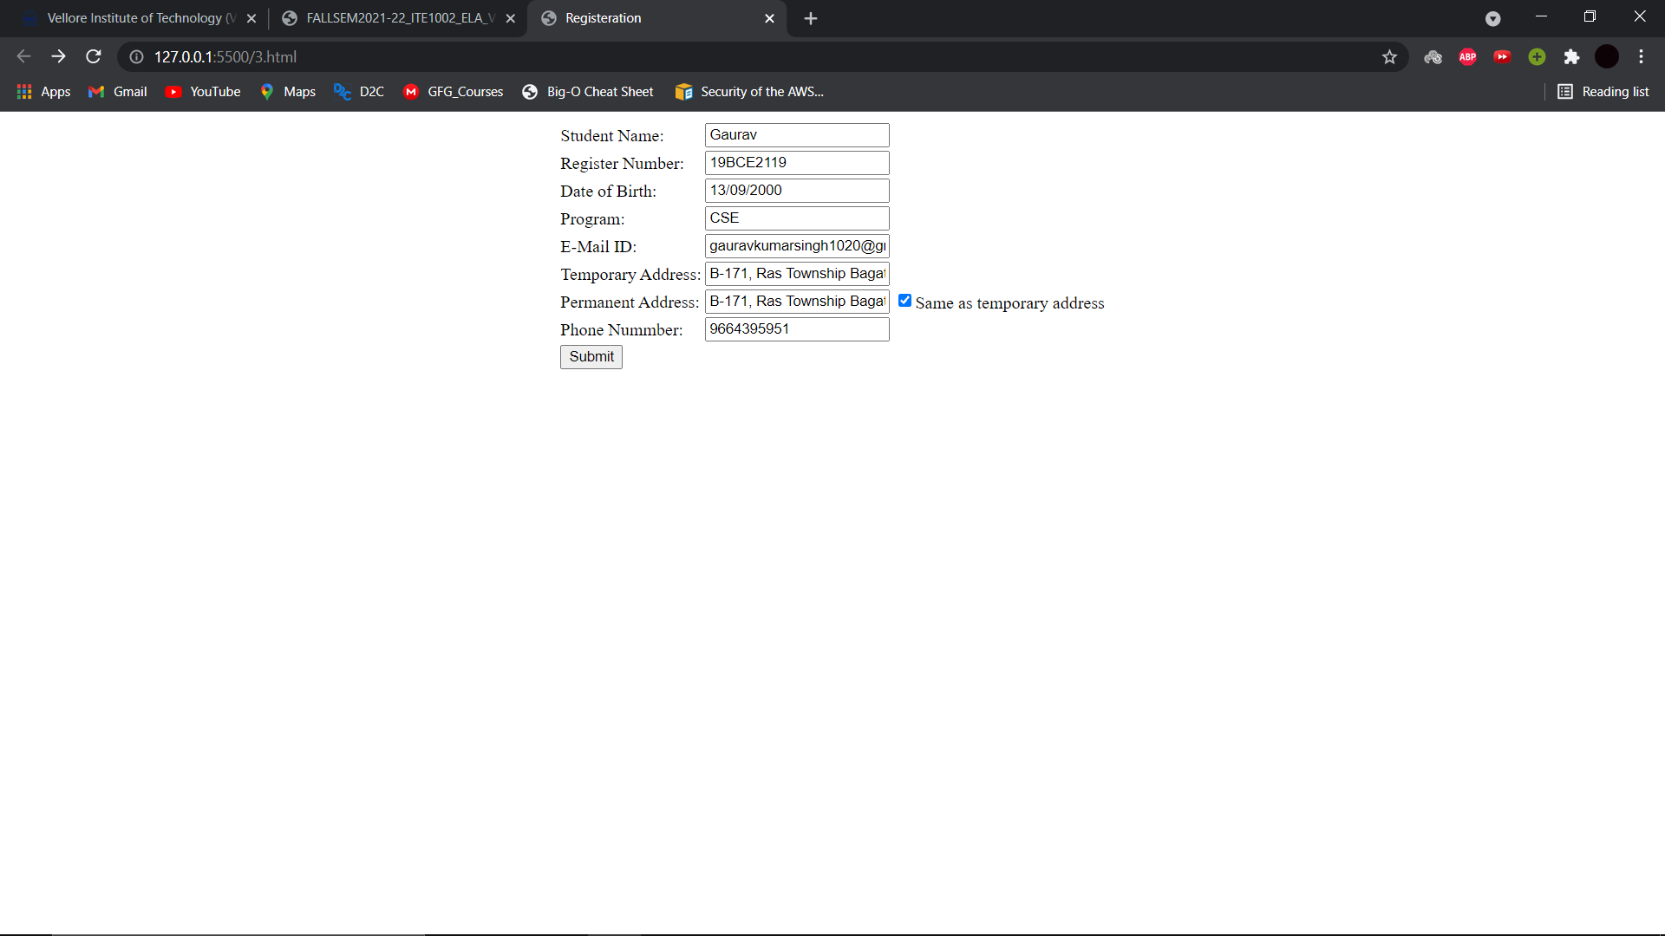

1. Write the JavaScript code to add behaviour to the following page for manipulating strings.

a) The page UI allows the user to type a phrase into a text box. The user can click the "Go!" button to display the words in that phrase in reverse order. Each word in the phrase should be inserted as a span with a class of word, inside a div with the id of words. Every other word (the first, third, fifth, etc.) should also be underlined

b) The user can optionally specify a "filter" text by typing into a text box with the id of filter. If a non-blank filter is specified, you should exclude any words from the phrase that contain that filter text, case-insensitively. For example, if the filter text is "abc", exclude any words containing abc, ABC, aBc, etc.

c) If any words are excluded, under the list of words you should modify the div with id of count to display text of the form, "5 word(s) filtered out". The code should work for multiple clicks of the button. On each click it should clear any previous information you injected. You may assume that words in the phrase are separated by single spaces.

d) These screenshots show the initial state, and after phrases have been typed and "Go!" is clicked

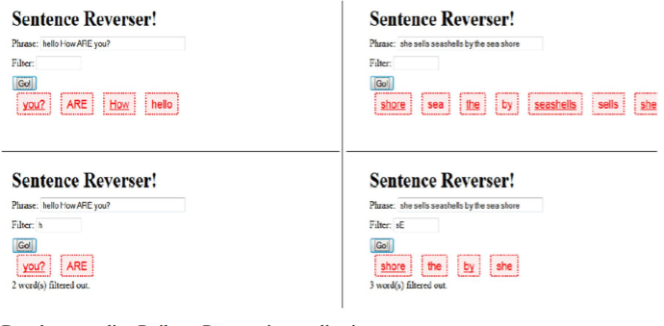

**CODE:**

**HTML**

<!DOCTYPE html>

<html lang="en">

<head>

    <meta charset="UTF-8">

    <meta http-equiv="X-UA-Compatible" content="IE=edge">

    <meta name="viewport" content="width=device-width, initial-scale=1.0">

    <title>Document</title>

    <script src="4.js"></script>

</head>

<body>

    <h1>Sentence Reverser!</h1>

    <form id="form">

        Phrase: <input type=text name=phrase><br/>

        Filter: <input type=text name=filter><br/>

    </form>

    <button onClick="Rev()">GO!</button>

    <div id="OP"></div>

</body>

</html>

**JavaScript**

function Rev(){

    let form= new FormData(document.getElementById("form"));

    op= document.getElementById("OP")

    //op.innerHTML("");

    phrase=form.get("phrase");

    filter=form.get("filter");

    var x=phrase.length;

    //op.innerHTML=filter;

    var arr= new Array();

    var j=0;

    var temp="";

    for(var i=0;i<x;i++){

        if(phrase[i]==' '){

            temp="";

        }

        else{

            while(phrase[i]!=' ' && i<x){

                temp+=phrase[i];

                i++;

            }

            arr[j]=temp;

            j++;

            i--;

        }

    }

    var y=filter.length;

    x=arr.length;

    if(y==0){

        filter=null;

    }

    for(var i=0;i<x;i++){

        if(filter!=arr[i].substr(0,y)){

            op.innerHTML=arr[i]+" "+op.innerHTML ;

        }

    }

    //op.innerHTML=x;

}

**SCREENSHOTS:**

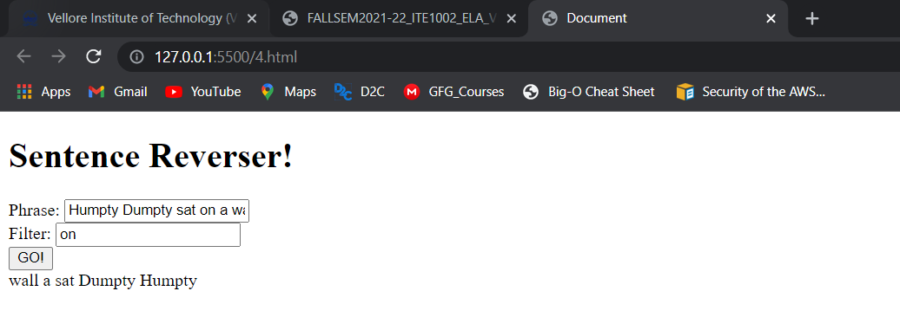

1. Develop an online Railway Reservation application.

a) It has top frame with the name “Online Railway Reservation System” in the middle, there is a logo/image in the left corner using suitable CSS styles and the left frame with the links for Ticket booking and availability checking; for each link the target should be the right frame.

b) Create a Ticket Booking form which should have From and To in a text box, Train Names in a drop down box, Coach Number in a list box, Date in a date field, Timing in a text box, Passengers Male and female in a dropdown menu showing the count number and Submit and Reset button.

c) Assume availability of tickets already declared in the script. Create a DOM event to display the ticket confirmation details on any HTML element when ticket is available otherwise display “tickets not available” by invoking any other DOM event.

**CODE:**

**HTML top**

<html>

<head>

    <style>

        body {

            background: lightblue

        }

        img {

            position: absolute;

            top: 2px;

            left: 5px;

        }

        h1 {

            margin: 0 auto;

            position: absolute;

            left: 25%;

            width: 50%;

            top: 25%;

            font-family: Roboto;

        }

    </style>

</head>

<body>

    <img src="irctc.png" alt="irctc logo" style="width:100px;height:120px" ;>

    <h1 align="center">Online Railway Reservation System</h1>

</body>

</html>

**HTML main**

<head>

    <meta charset="UTF-8">

    <meta http-equiv="X-UA-Compatible" content="IE=edge">

    <meta name="viewport" content="width=device-width, initial-scale=1.0">

    <title>Document</title>

    <script src="https://code.jquery.com/jquery-3.5.1.min.js"></script>

    <script src="./5.js"></script>

    <style>

        .right{

            right:0;

        }

    </style>

</head>

<body>

        <iframe src="5top.html" width=100%></iframe>

        <div  style="margin-top:20px">

            <table cellspacing="5px" style="border:2px solid black;width:60%" align="center">

                <form style=" margin:0;padding: 0">

                    <tr>

                        <td>Source Station</td>

                        <td>Destination Station</td>

                    </tr>

                    <tr>

                        <td><input type="text" placeholder="From" name=from></td>

                        <td><input type="text" placeholder="To" name=to></td>

                    </tr>

                    <tr>

                        <td>Train Name</td>

                        <td>Coach Number</td>

                    </tr>

                    <tr>

                        <td>

                            <select name=trainname>

                                <option value=RE>Rajdhani Express</option>

                                <option value=SE>Shatabdi Express</option>

                                <option value=GR>GareebRath</option>

                            </select>

                        </td>

                        <td>

                            <select name=coach>

                                <option>S1</option>

                                <option>S2</option>

                                <option>S3</option>

                                <option>A1</option>

                                <option>A2</option>

                                <option>A3</option>

                            </select>

                        </td>

                    </tr>

                    <tr>

                        <td>Date</td>

                        <td>Time</td>

                    </tr>

                    <tr>

                        <td><input type="date" name=date></td>

                        <td><input type="text" name=time></td>

                    </tr>

                    <tr>

                        <td>Gender</td>

                        <td>Count</td>

                    </tr>

                    <tr>

                        <td>

                            <select name=gender>

                                <option>Male</option>

                                <option>Female</option>

                                <option>Others</option>

                            </select>

                        </td>

                        <td>

                            <input type="number" name=Pcount id="pcnt">

                        </td>

                    </tr>

                    <tr>

                        <td><button id="btn">Submit</button>

                        <td><input type="reset"></td>

                    </tr>

                </form>

            </table>

            <div>

                <p style="color: green; display:none" id="success">*Tickets Booked</p>

            </div>

            <div>

                <p style="color: red; display:none" id="fail">*Tickets not available</p>

            </div>

        </div>

</body>

</html>

**JavaScript**

$(document).ready(function(){

    console.log("Hello");

    let availseats=10;

    $("#btn").on("click", function(event){

        event.preventDefault();

        let data = new FormData(document.querySelector('form'));

        data['count']=$('#pcnt').val();

        //console.log(data.count);

        if(data.count>10){

            $("#success").hide();

            $("#fail").show();

        }

        else{

            $("#success").show();

            $("#fail").hide();

        }

    })

});

**SCREENSHOTS:**

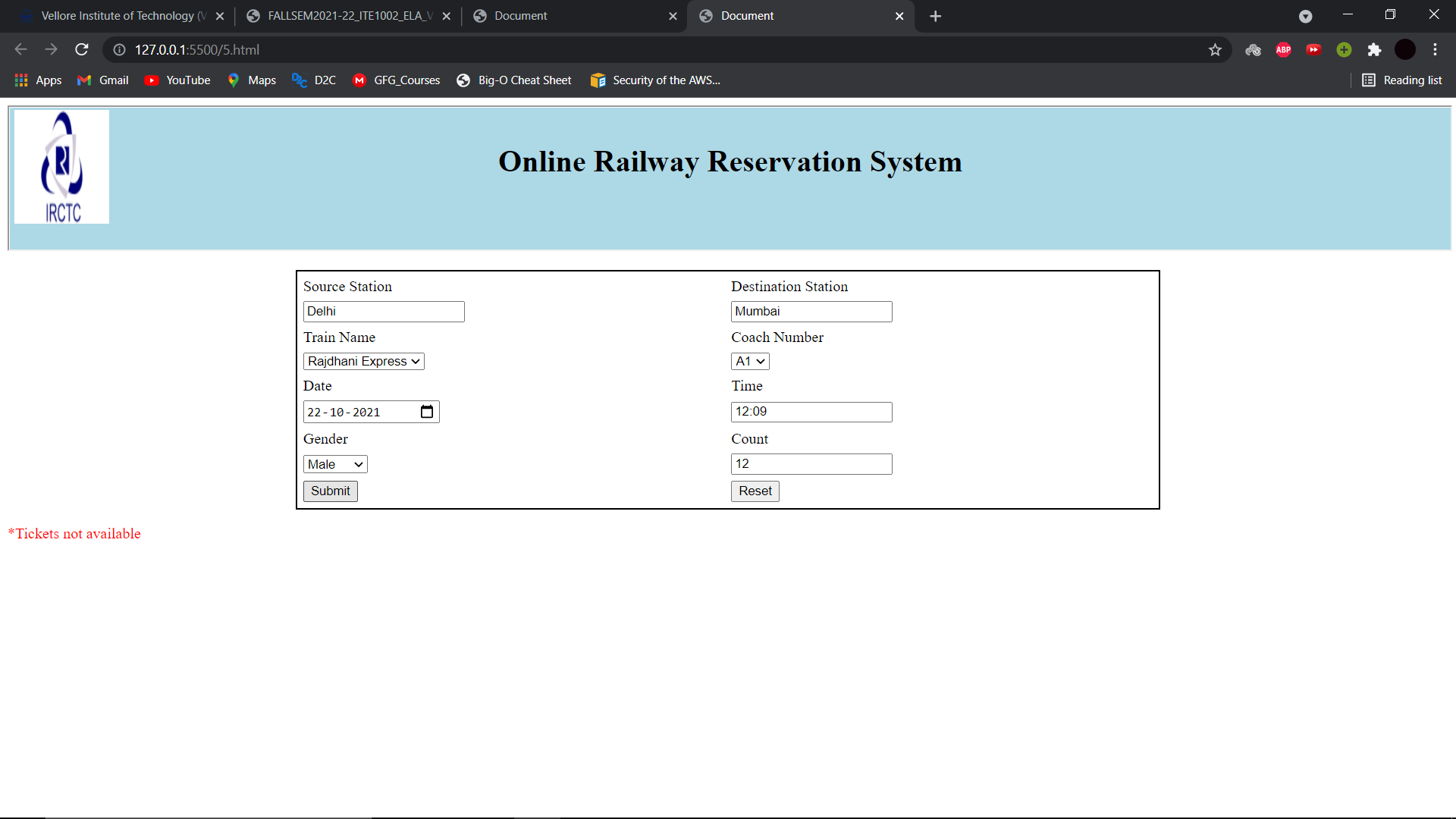

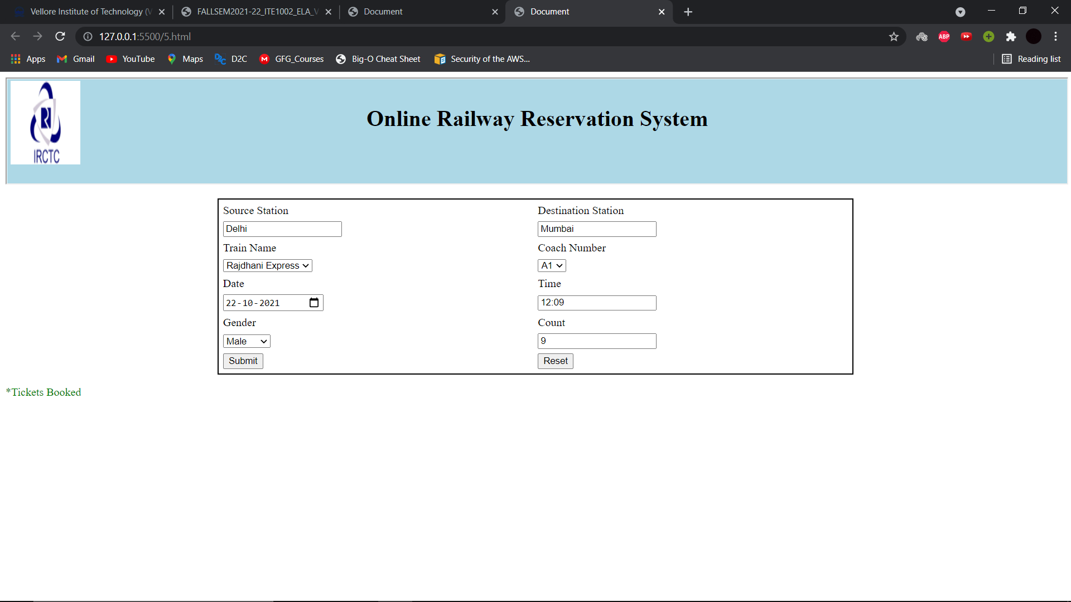

1. i) Design a table in the format given below using HTML and JQuery selectors.

ii) Apply different background for odd and even rows of the table.

iii) Apply different CSS for table header using JQuery selectors.

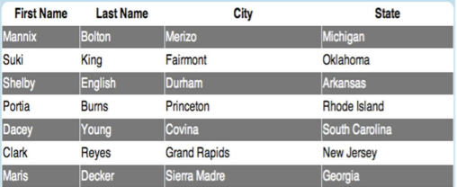

**CODE:**

**HTML**

<html>

<head>

<title>Table</title>

<script src="https://code.jquery.com/jquery-3.4.1.min.js"></script>

</head>

<body>

    <table>

    <thead>

    <tr>

        <th>First Name</th>

        <th>Last Name</th>

        <th>City</th>

        <th>State</th>

    </tr>

    </thead>

    <tbody>

    <tr>

        <td>Mannix</td>

        <td>Bolton</td>

        <td>Merizo</td>

        <td>Michigan</td>

    </tr>

    <tr>

        <td>Suki</td>

        <td>King</td>

        <td>Fairmont</td>

        <td>Oklahoma</td>

    </tr>

    <tr>

        <td>Shelby</td>

        <td>English</td>

        <td>Durham</td>

        <td>Arkansas</td>

    </tr>

    <tr>

        <td>Portia</td>

        <td>Burns</td>

        <td>Priceton</td>

        <td>Rhode Island</td>

    </tr>

    <tr>

        <td>Dacey</td>

        <td>Young</td>

        <td>Covina</td>

        <td>South Carolina</td>

    </tr>

    <tr>

        <td>Clark</td>

        <td>Reyes</td>

        <td>Grand Rapids</td>

        <td>New Jersey</td>

    </tr>

    <tr>

        <td>Maris</td>

        <td>Decker</td>

        <td>Sierra Madre</td>

        <td>Georgia</td>

    </tr>

    </tbody>

    </table>

    <script src="./6.js"></script>

</body>

</html>

**JavaScript**

$("td").css("padding","5px 10px");

$("th").css("padding","5px 10px");

$("tbody tr").css({"color":"white","background":"dimgray"});

$("tbody tr:nth-child(2n)").css({"color":"black","background":"white"});

**SCREENSHOTS:**

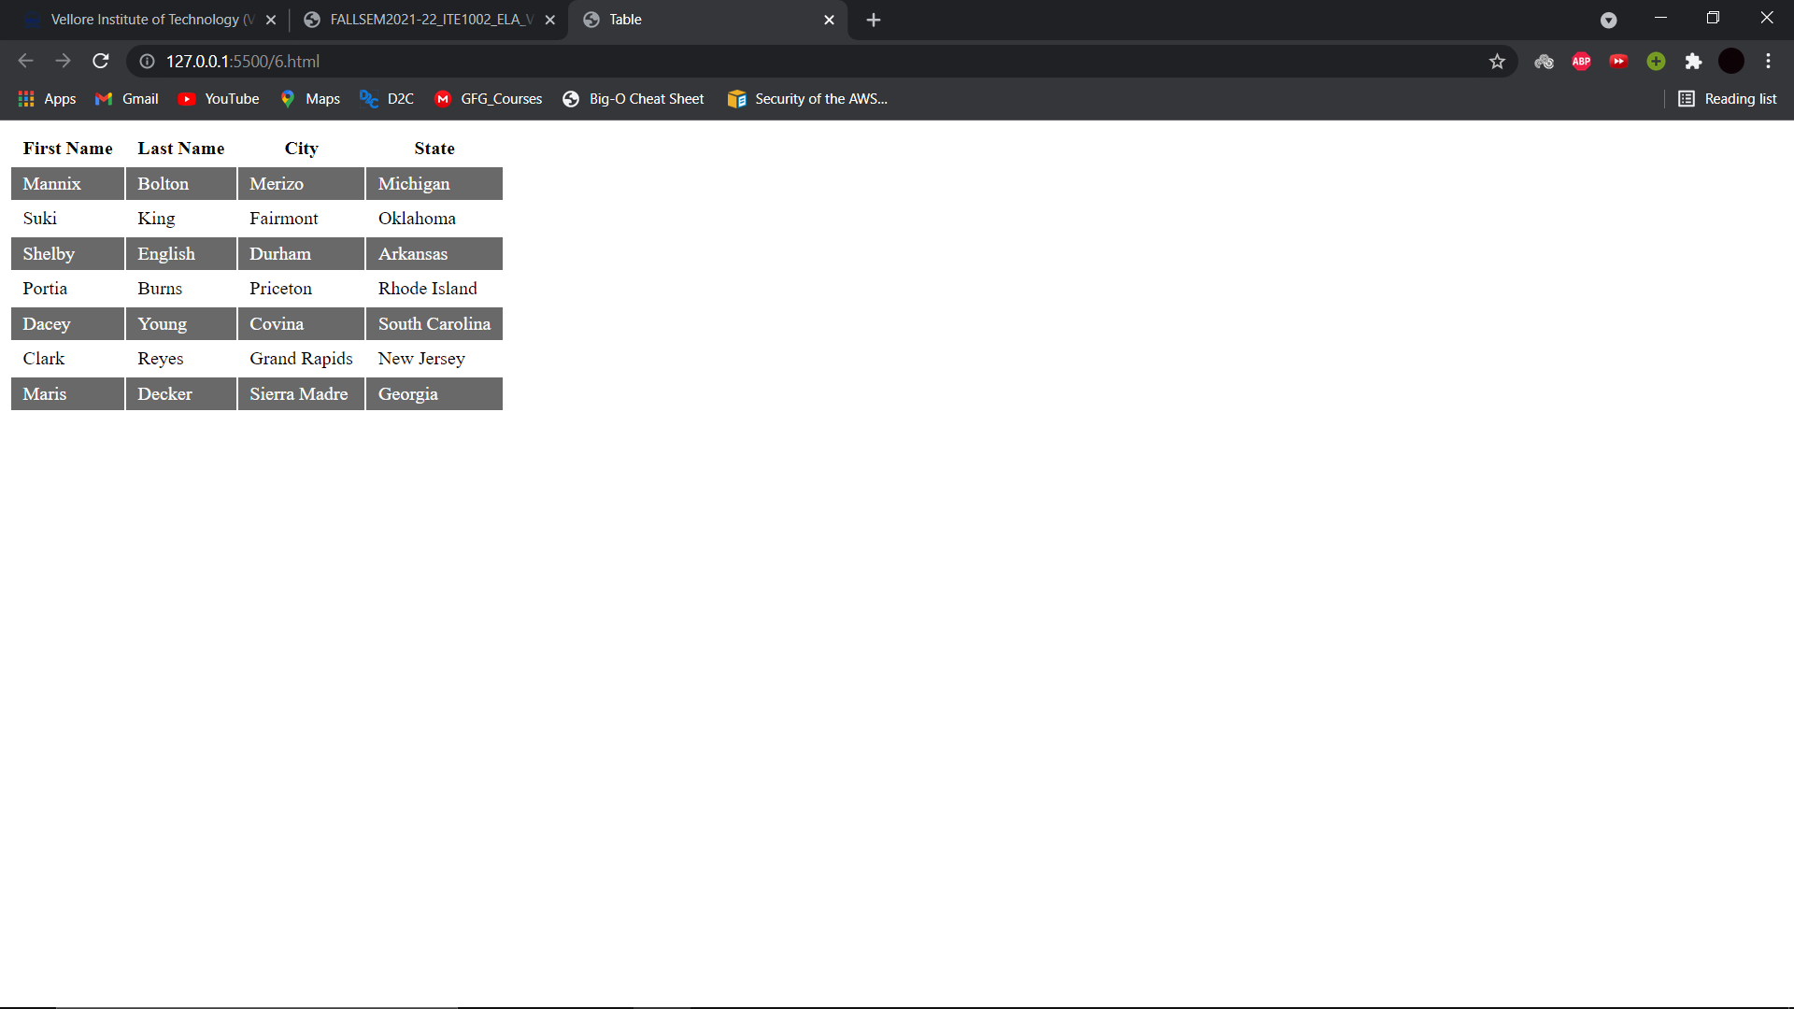

1. Write the JQuery code, so that when the Delete button is clicked, any button whose text value is divisible by the number written in the text field is removed from the page. You may assume that a valid number has been typed in the text field. The HTML code is the following: These screenshots show the initial page and its new appearance after typing 2 into the text field and pressing Delete:

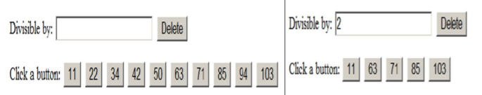

**CODE:**

**HTML**

<html>

<head>

    <script src="https://code.jquery.com/jquery-3.5.1.min.js"></script>

    <script src="7.js"></script>

    <style>

        .btns {

            margin-right: 10px;

        }

    </style>

</head>

<body>

    Divisible by :

    <input type="number" id="query">

    <button id="Dbtns">Delete</button>

    <br> Click A Button :

    <div id="buttons"></div>

</body>

</html>

**JavaScript**

$(document).ready(function(){

    for (var i = 0; i < 10; i++) {

        var n = Math.round(Math.random() * 1000) + 1;

        $('#buttons').append("<button class=\"btns\" value=" + n + ">" + n + "</button>");

    }

    //console.log("AAA")

    var Dbts = $("#Dbtns");

    console.log(Dbts)

    Dbts.on("click",function(e){

        //e.preventDefault();

        var nu = Number($("#query").val());

        console.log(nu);

        bts= $(".btns");

        for (var i = 0; i < 10; i++) {

            var d = bts[i];

            //console.log(d.getAttribute("value"));

            if (Number(d.getAttribute("value")) % nu == 0){

                console.log(d.text);

                d.style.display = "none";

                console.log("deleted");

            }

        }

    })

});

**SCREENSHOTS:**

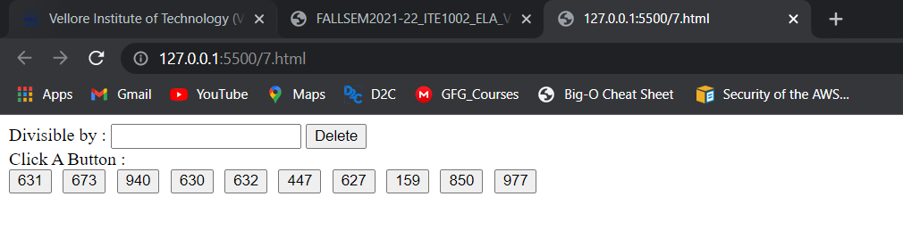

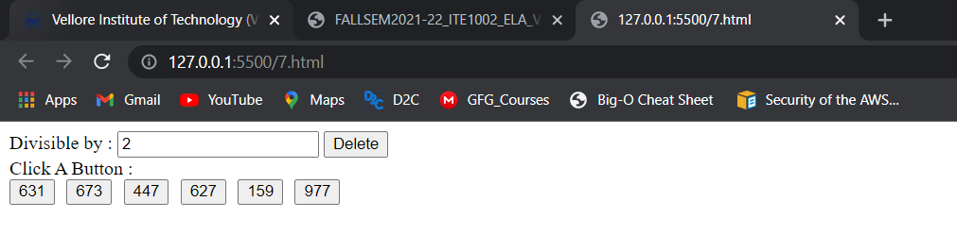

1. Write the JQuery code to add behaviour to the following page for keeping track of a to-do-list.

a) The page UI allows the user to type an item into a text box. The user can click the "add" button to add the item to the bottom of the list. Each word in the phrase should be inserted as a li, inside an ul with the id of list.

b) If the user wishes to remove an item he or she can type the text of the item he or she wishes to remove in the text box and click the “remove” button. This should be case insensitive. For example, if the list only contains “foo” and the user tries to remove “FoO”, it should be removed. If the user tries to remove an item that is in the list multiple times only the first occurrence should be removed.

c) The items should have background colours that alternate between white and yellow (first white, then yellow, then white, yellow, etc.). This should still be the case no matter how many items are removed or added and no matter what order these operations are done in. d) The code should work for multiple clicks of the buttons. On each click it should clear any previous information you typed in the input boxes.

These screenshots show the state after items have been added and the state after items have been removed.

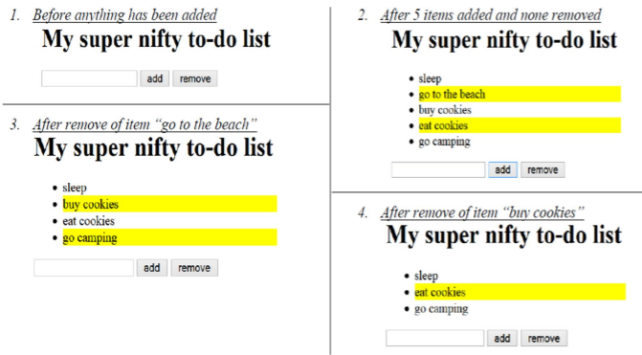

**CODE:**

**HTML**

<html>

<head>

<script src="https://code.jquery.com/jquery-3.4.1.min.js"></script>

    <style>

    li:nth-child(2n) {

        background: yellow;

    }

    #list {

        width: 200px;

    }

</style>

<title>To-do</title>

</head>

<body>

    <h1>My super nifty to-do list</h1>

    <ul id="list"></ul>

    <input type="text" id="inputField">

    <input type="submit" value="add" onclick="add()">

    <input type="submit" value="remove" onclick="remove()">

    <script src="./8.js"></script>

</body>

</html>

**JavaScript**

function add() {

    var str = $("#inputField");

    var s = "<li>" + str.val() + "</li>";

    $("#list").append(s);

    str.val("");

    }

    function remove() {

    var str = $("#inputField").val();

    str = str.toUpperCase();

    var d = $("#list").children();

    var n = d.length;

    for (var i = 0; i < n; i++) {

    if (d[i].textContent.toUpperCase() == str) { d[i].remove();

    break;

    }

    }

    $("#inputField").val("");

}

**SCREENSHOTS:**

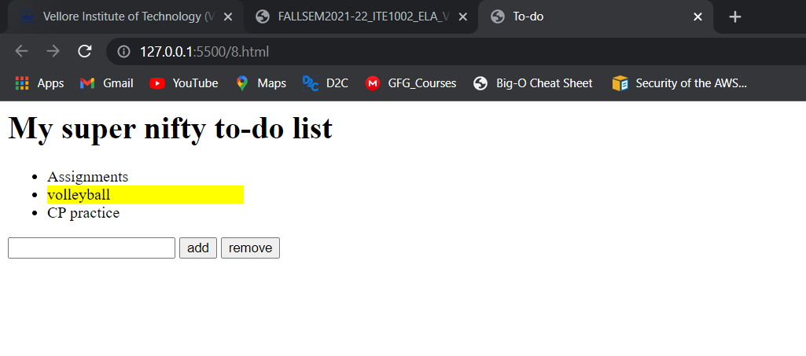

1. a) Validate the Event Registration Form given below using jQuery for the following conditions.

• All fields are mandatory

• Zip code should be exactly five digits

• Email validation

b) Create an array for a list of cities. Provide autocomplete option for city field using that array as a source.

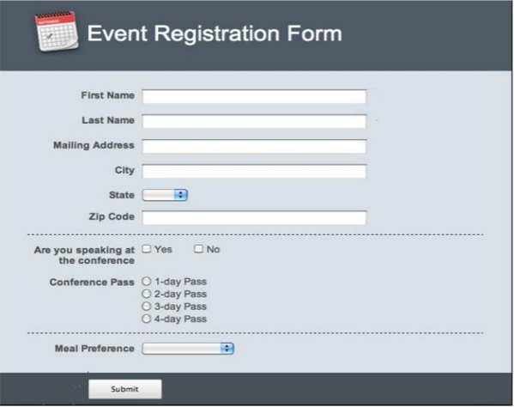

**CODE:**

**HTML**

<!DOCTYPE html>

<html lang="en">

<head>

    <meta charset="UTF-8">

    <meta http-equiv="X-UA-Compatible" content="IE=edge">

    <meta name="viewport" content="width=device-width, initial-scale=1.0">

    <title>Document</title>

    <style>

        .ui-autocomplete {

            position: absolute;

            top: 100%;

            left: 0;

            z-index: 1000;

            min-width: 100px !important;

            padding: 0px 10px;

            margin: 0 0 10px 25px;

            list-style: none;

            background-color: #f1f1f1;

            font-family: 'Ubuntu', sans-serif;

            text-transform:initial !important;

            font-size:14px;

        }

        .ui-state-hover, .ui-state-active {

            color: #001aff;

            cursor:pointer;

            padding-left:0px !important;

            padding-right:0px !important;

            border-radius: 0px;

        }

        body{

            background-color:rgb(207, 207, 207);

        }

        .headers{

            margin-top:-25px;

            width:100%;

            height:100px;

            background-color:rgb(75, 75, 75);

        }

        .headers h1{

            padding-top:25px;

            color:white;

        }

        .tag{

            text-align:right;

            width:150px;

            padding:10px;

        }

        .border-top{

            border-top: 2px dashed black;;

        }

        .sub-div{

            position:absolute;

            background-color:rgb(75, 75, 75);

            width:100%;

            height:30%;

            left:0;

        }

        #btn{

            margin-top:40px;

        }

        .autocomplete{

            overflow: auto;

            border: 1px solid #CBD3DD;

            background: #FFF;

        }

    </style>

    <script src="https://code.jquery.com/jquery-3.5.1.min.js"></script>

    <script src="https://code.jquery.com/ui/1.12.1/jquery-ui.js"></script>

    <script src="9.js"></script>

</head>

<body>

    <div class=headers align=center>

        <h1>Event Registration Form</h1>

    </div>

    <div id="err" style="color:red;display:none;">Form data incorrect</div>

    <div>

        <table align=center>

            <form id=form>

                <tr>

                    <td class=tag>First Name</td>

                    <td><input type=text required id=fname name=fname></td>

                </tr>

                <tr>

                    <td class=tag>Last Name</td>

                    <td><input type=text required id=lname name=lname></td>

                </tr>

                <tr>

                    <td class=tag>Mailing Address</td>

                    <td><input type=email required id=maddr name=maddr></td>

                </tr>

                <tr>

                    <td class="tag">City</td>

                    <td><input type=text required id=city name=city></td>

                </tr>

                <tr>

                    <td class=tag>State</td>

                    <td><select required id=state name=state>

                        <option value=R>Rajasthan</option>

                        <option value=M>Maharashtra</option>

                        <option value=G>Gujrat</option>

                        <option value=MP>Madhya Pradesh</option>

                    </select></td>

                </tr>

                <tr>

                    <td class=tag>Zip Code</td>

                    <td><input type=number required id=zcode name=zcode></td>

                </tr>

                <tr>

                    <td class="tag border-top">Are you at speaking at the conference</td>

                    <td class=border-top><input type=radio name=speaker required value=yes>Yes <input type=radio name=speaker required value=no>No</td>

                </tr>

                <tr>

                    <td class=tag>Conference pass</td>

                    <td><input type=radio name=pass required value=1dp>1-Day pass<br>

                        <input type=radio name=pass required value=2dp>2-Day pass<br>

                        <input type=radio name=pass required value=3dp>3-Day pass<br>

                        <input type=radio name=pass required value=4dp>4-Day pass<br>

                    </td>

                </tr>

                <tr>

                    <td class="tag border-top">Meal Preference</td>

                    <td class="border-top">

                        <select id=mealpref required name=mealpref>

                            <option value=V>Veg</option>

                            <option value=NV>Non-Veg</option>

                        </select>

                    </td>

                </tr>

                <tr>

                    <td rowspan=2 text-align=center><div align=center class=sub-div><button id=btn type="submit">Submit</button></div></td>

                </tr>

            </form>

        </table>

    </div>

</body>

</html>

**JavaScript**

$(document).ready(function(){

    $("#city").on("click",function(){

        var tags = [

            "Ajmer", "Jaipur", "Mumbai",

            "Nagpur", "Ahmedabad",

            "Gwalior", "Bhopal", "Udaipur", "Ujjain"

        ];

        $(this).autocomplete({

            source: tags

        });

    })

    $('#form').on('submit',function(e){

        e.preventDefault();

        formData = new FormData(this);

        formData['fname']=$('#fname').val();

        formData['lname']=$('#lname').val();

        formData['maddr']=$('#maddr').val();

        formData['city']=$('#city').val();

        formData['state']=$('#state').val();

        formData['zcode']=$('#zcode').val();

        formData['speaker']=$('input[name="speaker"]:checked').val();

        formData['pass']=$('input[name="pass"]:checked').val();

        formData['mealpref']=$('#mealpref').val();

        console.log(formData);

        nzcode=Number(formData['zcode']);

        var count=0;

        if (nzcode >= 1) ++count;

        while (nzcode / 10 >= 1) {

            nzcode /= 10;

            ++count;

        }

        if(count!=5){

            //console.log("as");

            $('#err').show();

            return false;

        }

        else{

            $('#err').hide();

        }

        return $('#form')[0].submit();

    })

});

**SCREENSHOTS:**

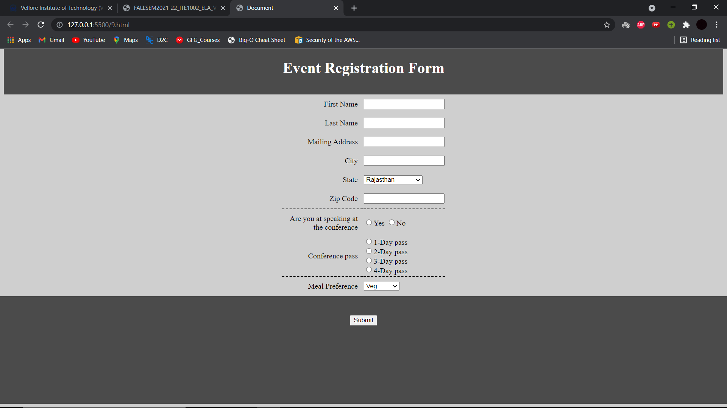

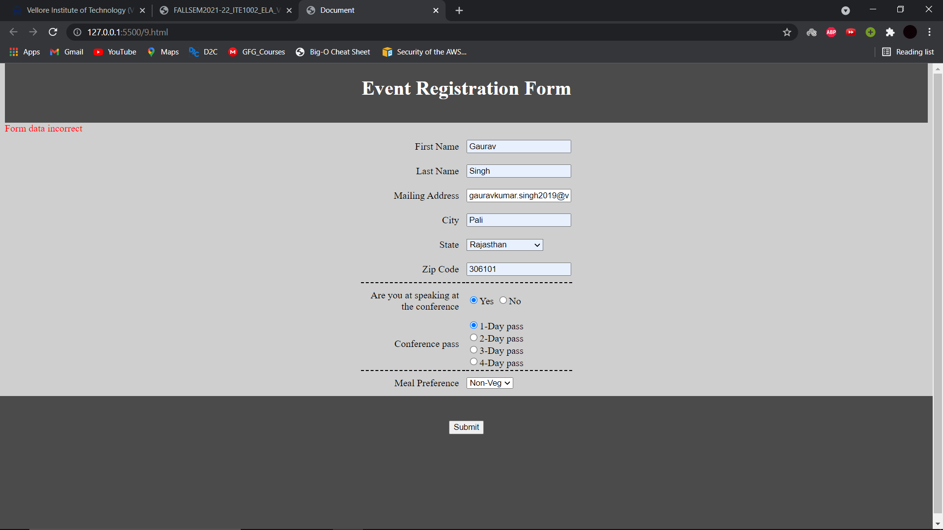

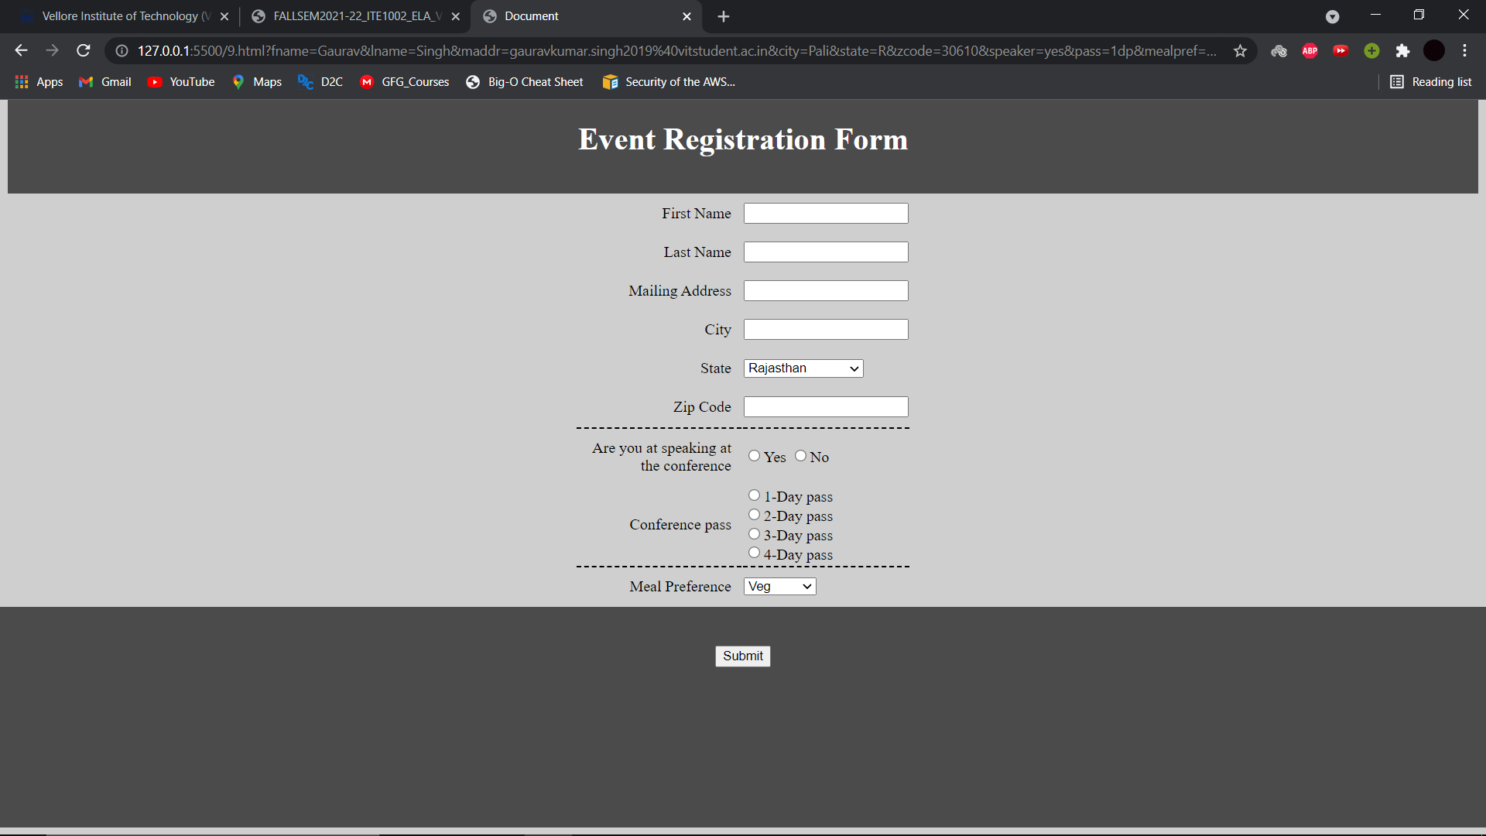

1. Write the XHTML code to create the form with the following capabilities

a) A text widget to collect the users name

b) Four check boxes, one each for the following items

i. Four 100 watt light bulbs for Rs. 20=39

ii. Eight 100 watt light bulbs for Rs 40=20

iii. Four 100 watt long life light bulbs for Rs. 30=95

iv. Eight 100 watt long life light bulbs for Rs 70=49

c) A collection of 3 radio buttons that are labelled as follows

i. Visa

ii. Master Card

iii. Discover

d) Computes the total cost of the ordered light bulbs for the above program after adding 13.5% VAT. The program must inform the buyer of exactly what was ordered in table.

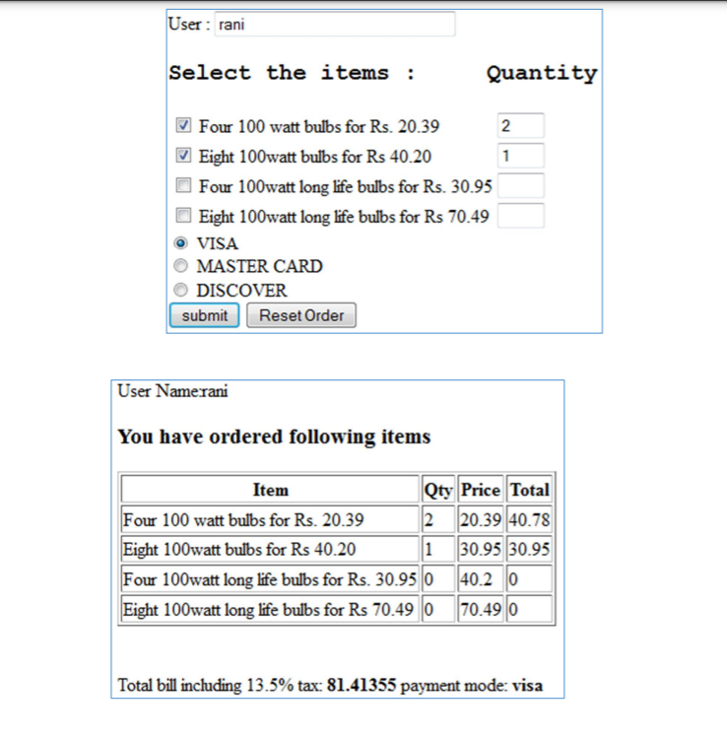

**CODE:**

**HTML**

<!DOCTYPE html>

<html lang="en">

<head>

    <meta charset="UTF-8">

    <meta http-equiv="X-UA-Compatible" content="IE=edge">

    <meta name="viewport" content="width=device-width, initial-scale=1.0">

    <title>Document</title>

    <script src="./10.js" type="text/javascript"></script>

</head>

<body onload="loadjson()">

    <form>

        User: <input type="text" name="mname" size=30 id="name"/> <br/>

        <b><h2><label id="heading" ></label></h2></b>

        <table>

        <tr>

        <td>

        <input type="checkbox" name="option1" checked="checked"/>

        <label id="chk1">Four 100 watt bulbs for Rs. 20.39 </label>

        </td>

        <td>

        <input type="text" id="q1" name="VAL1" size=2 />

        </td>

        </tr>

        <tr><td>

        <input type="checkbox" name="option2" />

        <label id="chk2">Eight 100watt bulbs for Rs 40.20 </label></td>

        <td>

        <input type="text" id="q2" name="VAL2" size=2/>

        </td>

        </tr>

        <tr>

        <td>

        <input type="checkbox" name="option3" />

        <label id="chk3">Four 100watt long life bulbs for Rs. 30.95 </label>

        </td>

        <td>

        <input type="text" id="q3" name="VAL3" size=2/>

        </td>

        </tr>

        <tr>

        <td>

        <input type="checkbox" name="option4" />

        <label id="chk4">Eight 100watt long life bulbs for Rs 70.49 </label><br/>

        </td>

        <td>

        <input type="text" id="q4" name="VAL4" size=2/>

        </td>

        </tr>

        </table>

        <input type="radio" id="r1" name="paymode" value="visa" checked="checked" /> VISA<br/>

        <input type="radio" id="r3" name="paymode" value="mcard"/> MASTER CARD <br/>

        <input type="radio" id="r2" name="paymode" value="discover"/> DISCOVER <br/>

        <input type="button" id="bt" value="submit" onclick="info()"/>

        <input type="reset" value="Reset Order" />

        <p id="result"></p>

        </form>

</body>

</html>

**JavaScript**

function loadjson(){

    var json = '{"h1": "Select the items : Quantity"}';

    var obj = JSON.parse(json);

    document.getElementById("heading").innerHTML=obj.h1;

    document.getElementById("heading").innerText=obj.h1;

}

var pay;

function info(){

    if(document.getElementById('r1').checked){ pay=document.getElementById('r1');

    }

    else if(document.getElementById('r2').checked){ pay=document.getElementById('r2');

    }

    else if(document.getElementById('r3').checked){ pay=document.getElementById('r3');

    }

    document.getElementById("result").innerHTML =

    "User name:"+document.getElementById("name").value + "<br/>"+ "<h2>You have ordered following items</h2></br>"+

    "<table border=2px><tr>" + "<td><b>Item</b></td>"+ "<td><b>Qty</b></td>"+

    "<td><b>Price</b></td>"+ "<td><b>Total</b></td>"+ "</tr>"+

    "<tr>"+

    "<td>Four 100 watt bulbs for Rs. 20.39</td>"+"<td>"+document.getElementById("q1").value+"</td>"+ "<td>20.39</td>"+

    "<td>"+document.getElementById("q1").value*20.39+"</td>"+ "</tr>"+

    "<tr>"+"<td>Eight 100watt bulbs for Rs 40.20</td>"+ "<td>"+

    document.getElementById("q2").value+"</td>"+ "<td>40.20</td>"+

    "<td>"+document.getElementById("q2").value*40.20+"</td>"+ "</tr>"+

    "<tr>"+

    "<td>Four 100watt long life bulbs for Rs. 30.95</td>"+

    "<td>"+document.getElementById("q3").value+"</td>"+ "<td>30.95</td>"+

    "<td>"+document.getElementById("q3").value*30.95+"</td>"+ "</tr>"+

    "<tr>"+

    "<td>Eight 100watt long life bulbs for Rs 70.49</td>"+

    "<td>"+document.getElementById("q4").value+"</td>"+ "<td>70.49</td>"+

    "<td>"+document.getElementById("q4").value*70.49+"</td>"+

    document.getElementById("q3").innerHTML*30.95 + document.getElementById("q4").innerHTML*70.49+"</table><br>"+

    "Total bill including 13.5% tax :<b>"+

    1.135*(document.getElementById("q1").value*20.39 + document.getElementById("q2").value*40.20 +

    document.getElementById("q3").value*30.95 + document.getElementById("q4").value*70.49) +

    "</b> payment mode: " + pay.value;

}

**SCREENSHOTS:**

